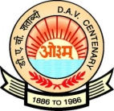
NIRJA SAHAY DAV PUBLIC SCHOOL, KANKE, RANCHI
Summer Camp (MUSIC) from 8th to 11th June 2020-21 (III – VII)
Timing - 9:30 am to 11:00 am
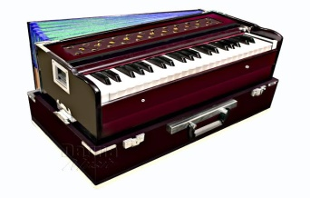
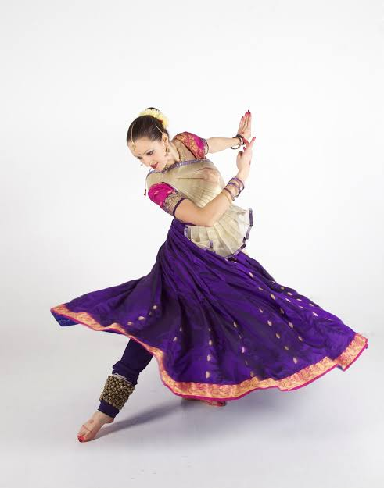

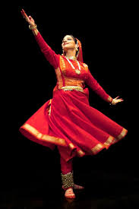
- Harmonium
- Tabla
- Triple
- Dholak Naal
- Octapad
- Flute
- Cajon
- Define the following:
Music, Laya, Aroh,Avroh, Vadi and Samvadi, Anuvaadi.
- Alankar Practice, simple and Merukhand
- Basic knowledge of raga yaman and bhupali. Chhota khayal with 4 taans ( 8 matras and 16 matras) one devotional song each day.
- Flute – How to blow the main hole of the flute and to use the fingers on the holes
- Alankar Practice – Basic knowledge of Raga Yaman Chhota Khayal and Taan
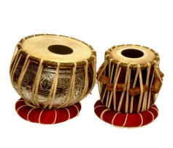
- Tabla – (i) How to keep fingers on table.
(ii) How to play different varnas of Tabla.
(iii) One kaydaa in teental with Dugan and Chougun
with Tihai.
Taal notation of Teental
Dadra and Keharva ( Taali/ Khaali )
- How to play Dadra and Keherva beats on triple, drums, octapad and
Cajon with rollings..
*****From Department of Music******

