 |  | Class VII (Activity List)
 | S. No. |  | Name of lession | Month | Activity | Page No | Mode Of Assessment
 | 1 |  | The Evolution of Computer | April-May | Activity I | 2 | ASL
 |  |  |  |  | Activity II | 10 | ASL
 | 2 |  | Scratch-I | June | Activity I | 25 | HANDS ON
 |  |  |  |  | Activity II | 26 | PEN PAPER
 | 3 |  | Scratch-II | July | Activity I | 28 | PEN PAPER
 |  |  |  |  | Activity II | 30 | PEN PAPER
 | 4 |  | Introduction to GIMP | August | Activity I | 53 | HANDS ON
 |  |  |  |  | Activity II | 68 | HANDS ON
 | 5 |  | GIMP Tool | September | Activity I | 77 | HANDS ON
 |  |  |  |  | Activity II | 88 | HANDS ON
 | 6 |  | Advanced GIMP | Oct-Nov | Activity I | 104 | HANDS ON
 |  |  |  |  | Activity II | 111 | PEN PAPER
 | 7 |  | Basic of Internet | December | Activity I | 114 | PEN PAPER
 |  |  |  |  | Activity II | 125 | PEN PAPER
 | 8 |  | Internet & Web Services | January | Activity I | 131 | PEN PAPER
 |  |  |  |  | Activity II | 139 | PEN PAPER

APRIL- MAY
The Evolution of Computer

ASSESSMENT I
Link:https://youtube/LvKxJ3bQRKE

- First counting device.______________
- Analytical engine was developed by ________________
- Who developed the punch card __________________
- The code in encrypted form is called as____________.
- The first network is _______________.

ASSESSMENT II
Link: https://www.youtube.com/watch?v=LJ5c3AycRIE

- How many generations of computer are there?
- Name the electronic device used in first generation computers?
- In which generation high level languages were developed?
- Which generation of computer used Microprocessor?
- What is the full form of IC?

JUNE
Scratch-I
ASSESSMENT I HANDS ON

Q.Create a Park scene . Add more sprite to this space.

ASSESSMENT II PEN PAPER

Q. Write the function of the following :
- Duplicate……………………………….
- Delete……………………………………….
- Grow………………………………………
- Shrink…………………………………….
- Presentation mode ……………………………………

JULY
Scratch-II
ASSESSMENT I PEN PAPER

Q. Tick the block having desired shape:-
Block name  Shape | Motion | Control | Looks | Sensing | Pen | Sound | Operators | Variable
HAT Block
STACK Block
Boolean Block
Reporter Block
Cap Block

ASSESSMENT II PEN PAPER
Q. Match the following:-

Column A Column B
- Motion Block To control a script
- Control Block Change the appearance of sprite
- Pen Block To sense the mouse and Keyboard
- Looks Block Used as a writing instrument
- Sensing Block To move the sprite

AUGUST
Introduction to GIMP
ASSESSMENT I HANDS ON
Q. Try to open an image already stored in your computer. Mention the name of the folder which you opened the file. Also name the file you opened.

ASSESSMENT II HANDS ON
Q. Draw a rectangle of blue color and fill it with yellow color. Also write your name inside the rectangle.

SEPTEMBER
GIMP Tool
ASSESSMENT I HANDS ON
Label any five tools in the image given below-

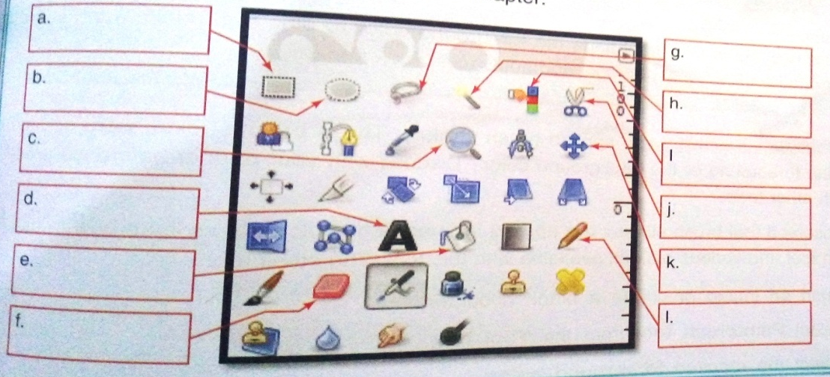

ASSESSMENT II HANDS ON
Q. Draw clouds using GIMP. Now use the blur tool to make the edge of the clouds blur.

OCT-NOV
Advanced GIMP
ASSESSMENT I HANDS ON

Q. Open any image in GIMP and try the masking effect to show only the desired part of the image.

ASSESSMENT II PEN PAPER
Q. Write the keyboard shortcut of the following:
- Paintbrush Tool
- Flip Tool
- Rotate
- Blend
- Blur Tool

DECEMBER
Basic of Internet
ASSESSMENT I PEN PAPER
Q. Name any five web browser and draw the logo of the same.

ASSESSMENT II PEN PAPER
Q. Name any five social networking websites.

JANUARY
Internet & Web Services
ASSESSMENT I PEN PAPER
Q. List any five advantages of email.

ASSESSMENT II PEN PAPER

Q. Find out and write the names of e-shopping website from where we can buy the items listed below:
Item Name | website
Clothes
Books
Toys
Electronic devices
Cars

