DAV PUBLIC SCHOOLS, HAZARIBAG ZONE
ASSESSMENT PLAN 2017-18
SUB- COMPUTER
STD- VIII
Sl.No | Month | Name of the chapter | Activity | Mode of Assessment
1 | April-May | Computer Network and HTML-I | - How Internet works? (page-18-LINKS)  - Creating Web page (pg-49) | - ASL  - Practical based
2 | June-July | List and Tables in HTML | - Write a HTML code (pg-60)  - Assessment Activity-I(pg-72) | - Practical based  - Pen and paper
 |  | HTML-III | - Different types of Linking(Pg-83)  - Design a Webpage (pg-89) | - ASL  - Pen & paper
3 | August | Identifying networked resources and computer | - Web Browsers (Pg-90)  - Activity Based (Pg-93) | - ASL  - Pen & Paper
4 | September | Problem solving | - Flow Chart(Pg-110)  - Compiler and Interpreter (Pg-120) | - ASL  - Pen & Paper
5 | October-November | Programming with QBASIC | - Card Game(Pg-139)  - Assessment Activity (Pg-144-145) | - Practical Based  - Pen & Paper
6 | December | Looping in QBASIC | - Do’s and Don’ts of a Project(Pg-155)  - HTML code - Any two(Pg-159) | - Pen & Paper  - Pen & Paper
7 | January | The cyber world, Cyber Crime and The Law | - Cyber Bully (Pg-160-163)  - Cyber Crime and Cyber Law(Pg-168-173) | - ASL  - ASL

DAV PUBLIC SCHOOLS, HAZARIBAG ZONE
ASSESSMENT PLAN 2017-18
SUB- COMPUTER
STD- VIII
Month-April- May
Name of the chapter- Computer Network and HTML-I
Activity Name-
1. How Internet works? (Page-18-LINKS – https://www.youtube.com/watch?v=jKA5hz3dV-g)
a. The global network of interconnected computers is called_____________
b. Vast collection of digital pages is called_____________
c. Where does the digital pages get stored___________
d. ________ % international digital traffic travels under sea water connecting multiple continents.
e. Thousands of fibre optic cables running under sea water is known as ______________
2. Creating Web page (pg-49)- Pen & Paper
- Choose the title for the webpage as “PRINTING”.
- Set the TEXT color to be YELLOW for the entire page.
- Apply BOLD and ITALICS on the heading “3D PRINTING”.
- Choose font type “ALGERIAN” for the entire page.
- Add horizontal rule in gray color, below the heading only.
Month- JUNE - JULY
Name of the chapter- List and Tables in HTML
Activity Name-
- Write a HTML code (pg-60)
Write a program to get the following Output-
- ELECTRONICS
  - LAPTOPS
  - MOBILES
    - APPLE
    - NOKIA
      - ASHA
      - LUMIA
        - LUMIA 520
        - LUMIA 720
- Assessment Activity-I (pg-72)
Sr. No. | Roll No. | Name | Team
1 | 1001 | John | Red
2 | 1002 | Peter | Blue
3 | 1003 | Henry | Green

Month-JUNE - JULY
Name of the chapter- HTML-III
Activity Name- LINK
- Different types of Linking (Pg-83)
  - Internal
  - External
- Design a Webpage (pg-89)
  - The webpage should have three webpages.
  - The right arrow on the homepage should link us to second page.
  - Second page will have names of at least 5 different veg. burgers with Image.
  - The right arrow on the second page should link us to third page.
  - Use appropriate background colors, text colors, font sizes and font styles.

Month-AUGUST
Name of the chapter- Identifying networked resources and computer
Activity Name-
- Web Browsers (Pg-90)
Write the names of Five web browsers commonly used in computer and Smartphone.
- Activity Based (Pg-93)
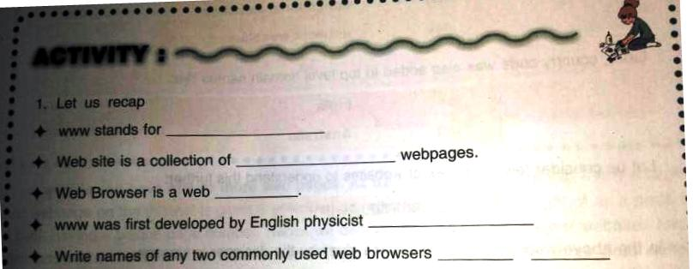

Month-SEPTEMBER
Name of the chapter- Problem solving
Activity Name-
- Flow Chart(Pg-110)
Prepare a Flowchart to find the sum of two numbers.

- Compiler and Interpreter (Pg-120) –
Write any three differences between compiler and interpreter.

Month-OCTOBER-NOVEMBER
Name of the chapter- Programming with QBASIC Activity Name-
- Flow Chart
Draw a flowchart to find the largest amongst two number.
2. Assessment Activity (Pg-144-145)
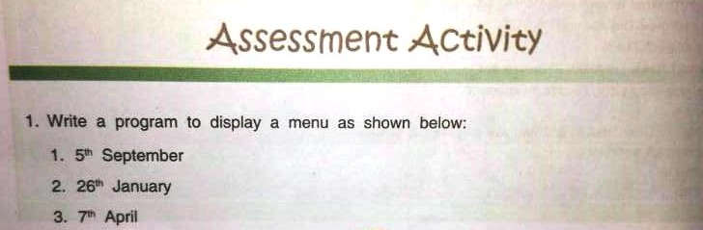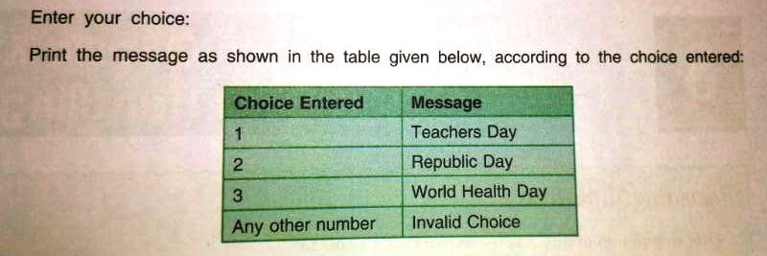

Month-DECEMBER
Name of the chapter- Looping in QBASIC
Activity Name-
1.Program(Pg-159)

Month-JANUARY
Name of the chapter- The cyber world, Cyber Crime and The Law
Activity Name-
- Cyber Bully ASL (Pg-160-163)
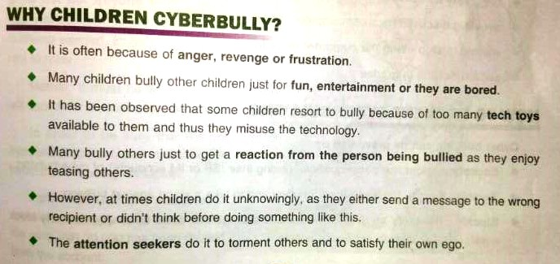

2. Cyber Crime and Cyber Law ASL (Pg-168-173)
